Coursera Capstone
Samuel Rosean

Denver City Sorting Tool

Introduction/Business Problem:
- Imagine a person seeking a home or apartment in the city of Denver who does not know which neighborhood will best match their interests and wants. The realty company which could provide them a tool to search the businesses of every Denver neighborhood and rank those neighborhoods based on the density of certain business types would be the obvious choice for their realty business. Take for example a prospective homeowner who wants to live in a neighborhood with a wide range of available fitness centers, and also a wide range of choice in italian food. A tool which could rank neighborhoods based on the overall amount of these business types within a neighborhood would provide your customer with the ideal method of honing their search.

Data:
- Utilizing geodata from Open Data Soft on Colorado postal codes and their respective latitude/longitude we can create a map of every distinct neighborhood in the Denver metropolitan area. Combining this with foursquare business/venue data we can create a combined data table of the amount of every business type within the city. Then, with this table’s data normalized we can then create a dotted heat map of the Denver area which will indicate where the selected business type is most common.
  - This Open Data Soft data is contained within the github project under the name “us-zip-code.csv”.

Methodology:

  - The data, as given by Open Data Soft contains the geographic coordinates and zipcode associated with every postal code in the state of Colorado.

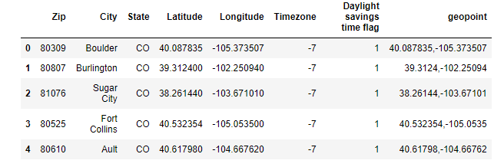

From this we will remove all non-Denver zip codes, and remove all unnecessary data so that the information we desire looks more like this:

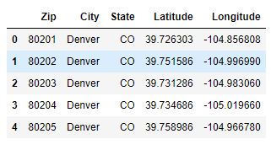
To ensure these points align reasonably well with our expectations, we plot them onto a map of the city using Folium.

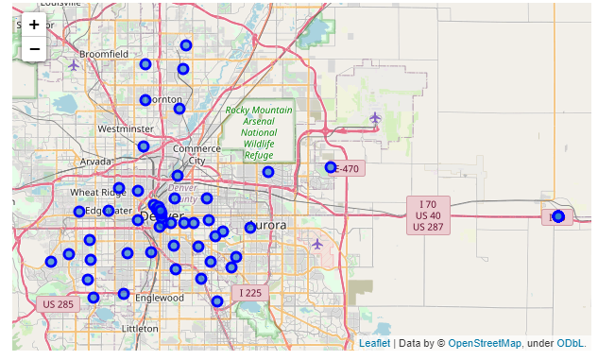

As we can see in our data here, there are a few far away postal codes that we wouldn't expect to be included. This is the Denver airport which is for various reasons included in the Denver metropolitan area. There are no houses available here and it is not a reasonable inclusion in our housing tool, so we remove these data points.

  - Using these latitude and longitude values we can make a call to receive a list of businesses within 1000 meters of each postal code’s center.

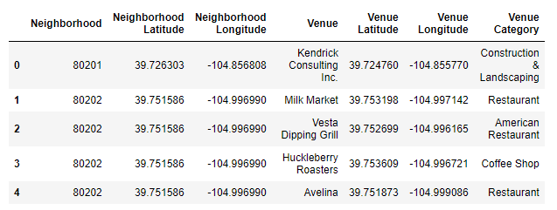

We then combine this data into sums, counting each business’ venue category to receive a master list of each neighborhood's count for every present venue type. In this way, if 80201 has 10 coffee shops, then it will have a ten count in the respective column. We then perform a normalization process to receive an integer value of each neighborhood count. We divide every neighborhood’s values by the highest possible value in its own column, creating a fraction relative to the maximum. So if a neighborhood has 6 coffee shops and the max value that any one neighborhood has is 12, in that first neighborhood’s column value there will be a 0.5 (equal to 6/12). To convert these values into integers we simply round them to decimal places and multiply by 100. The final result was this:

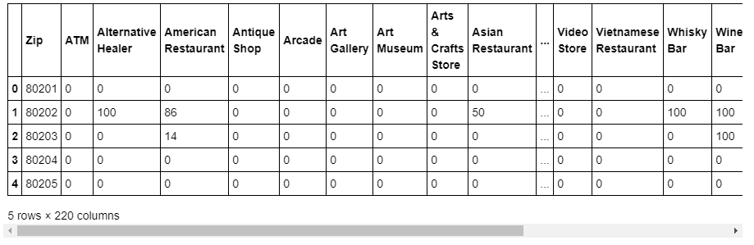

From here, it’s as simple as requesting the user to simply pick one of the available 220 business types and we can then map it using a blue to green heatmap-style color indicator. Here we have mapped yoga studios across Denver and you can find the highest density in 80261.

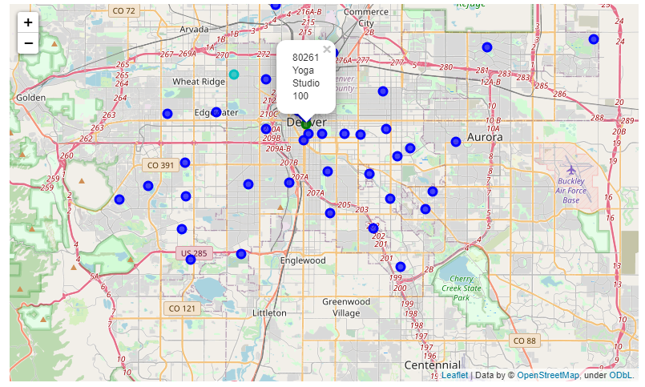

Results:
- The tool for visualizing Denver neighborhoods based on certain business types has been completed. A normalized value for each business type and a map which can render this in terms of color gradient between lowest (blue) and highest (green) is possible within the ipython notebook. The results, in so much as they can be confirmed with rough expectations, seems to conform to my own expectations of the city. Yoga Studios primarily occur in the city’s center, coffee shops in the less dense neighborhoods around the city center.

Discussion:
- There are a great deal of obvious graphical and data based errors within the current model.
  - Within the graphical representation of the data there are a few obvious problems
    - The actual physical boundaries and shape of each neighborhood are absent, making it difficult to parse what neighborhood includes what.
    - The color mapping lacks a robust system for differentiation the differences of most neighborhoods when there are outliers which are much denser with the intended business type. An s-curve style color space may be more useful for this purpose.
  - Within the data itself there are a multiple apparent issues
    - Foursquare data is pulled for each neighborhood within a radius from each city center. This data would be more useful limited to within the area code generally to avoid capturing other areas’ businesses, and to avoid missing business within larger or more oblong districts.
    - The foursquare calls possible within the free api is limited, but ideally the best data would come from pulling every single listed business within every area code to create less random sampling error. This could also be worked around by using multiple calls to create multiple random datasets, if it is indeed random which business Foursquare provides.

Conclusion
- We have created a tool which can be utilized to give an indication to a prospective homeowner what neighborhoods have the most of any selected business type. With this information a homeowner can hone in their home-buying search towards neighborhoods which best reflect their interests and desires. The tool adequately shows through heat-map dot plotting a visual representation of what neighborhoods are best for these. The tool currently lacks a more precise visual presentation and a large enough dataset to be wholly accurate, but it is generally indicative of these neighborhoods' qualities.

